A Design Tool to Determine and Maximize the Efficiency
Of Alcohol-Fueled Hiking Stove Systems:

By:
atraildreamer

With the valuable assistance of:

Jason Klass

Note: We assume no responsibility for anything you do with the following information on this page. If you blow up your stove, or yourself, or if you burn down the house -- too bad. Consider yourself warned and us indemnified. Use caution at all times! Keep a fire extinguisher handy!

This article assumes that the fuel used for the test(s) will be alcohol. The authors also reminds the reader/user that the fuel quantities generated by the spreadsheet that accompanies this article are theoretical, and the reader/user should always have sufficient alcohol fuel available to account for changing hiking conditions.

DO NOT USE GASOLINE!!!

Stove System Efficiency:

This article was originally conceived as a means to present a method of comparing alcohol-fueled hiking stoves, both homemade and commercial.

There have been numerous posts regarding the performance of these stoves. There is always the question of how can a comparison be made between an open-center, top-burner Pepsi can stove, a side-burner, a pre-heat, closed-center stove, a cat stove, a tea light stove with a wick, a Brasslite, a Trangia, etc. To add to the confusion, does the stove have a pot stand or a windscreen? There is also a difference between the various types of alcohol fuels available, denatured alcohol (SLX), methanol- or isopropyl-based dry gas, or ethanol (Everclear)? How much fuel is being used? What is the starting temperature of the water that is being heated? What is the outside air temperature?

How is the stove used? What is the height between the stove and the pot/pan that is being used? Is a titanium pot, a Wal-Mart grease pot, a Heinie pot, an aluminum pot from a Boy Scout cook kit, or Sgt Rock's much sought after titanium wok being used?

The above-mentioned factors give rise to a multitude of conflicting answers, the “apples vs. oranges” question, when trying to determine stove performance.

To cut through all of the confusion, we would like to offer a possible method of comparison of various stove systems, which may also allow the user to improve the performance of their particular stove system.

Definition: A stove system is a configuration of a burner, pot stand, windscreen, and pot/pan, which works for you.

To compare the performance of the various types of stove systems, we have to have a common, and easily reproducible, basis for comparison.

The heating of water is the obvious choice to use for this comparison.

Premise of the test:

If a volume of water requires a specific number of BTU's of heat energy to raise the temperature of the water from a known starting temperature to an expected final temperature, then a volume of fuel that contains the required number of BTUs is measured out.

Assuming 100% efficiency, the fuel will raise the water to the expected final temperature. But since nothing is 100% efficient, the final temperature of the water will lower than the expected temperature. Therefore, the higher the final water temperature, the higher the efficiency of the stove system. A comparison of the expected final temperature and the actual final temperature will allow a calculation of the efficiency of the stove system.

Setting up the Efficiency Test:

(The following quantities are just a suggested starting point. Other than the BTU content of the various fuels listed, none of this is carved in stone. Use whatever quantities you find convenient. The attached spreadsheet will allow you to enter data in either Fahrenheit or Centigrade, and will calculate fuel quantities in either fluid ounces or milliliters (CCs).)

DO NOT USE GASOLINE!!!

As an example, let’s start with 16 ounces (2 cups), (1.25pounds) of water as a standard volume, 2 cups being a typical amount of water used by backpackers when cooking.

A final expected temperature could be 212 degrees Fahrenheit (100 Degrees Centigrade), the aim not to get the water boiling, but just to raise it to just before the boiling point.

Using water that has been refrigerated could easily standardize the initial temperature of the water. This would be approximately 34 degrees F (1 degree C), but this will vary depending on the refrigerator.

It takes 1 BTU (British thermal unit) to raise the temperature of 1 Lb of water 1 degree F. So to raise 1.043 pounds (16 liquid ounces of water) 178 degrees F (212 F-34 F=178) we would need 185.7 BTUs (178 BTU/lb x 1.043 Lb).

(For methanol (=10,200 BTU/pound=19.5 fluid oz=576.6 ml) was used, then a volume of 0.35 liquid ounces (10.4 ml), containing the required 185.7 BTUs would be needed to raise the 16 ounce volume of water 178 degrees F (99 degrees C).

(185.7 BTU/10,200 BTU-lb)(576.6 ml)=10.4 ml

Then a comparison of the actual final temperature of the water to the expected final temperature of a theoretical
100 % efficient stove system will reveal the actual efficiency of the stove system.

(Don’t let the prospect of calculating specific numbers scare you—the attached spreadsheet will do all the hard work for you ☺)

Items Needed For The Test:

An accurate thermometer is required. I purchased a digital thermometer at Target for $5.99. It has a temperature range of -40 F to +450 F, and also reads in Centigrade, but use what you have available. The only requirements are that the thermometer is accurate and can measure up to the boiling point of water (212 F/100 C). A candy thermometer might be a good choice, but the low-end range of these is usually +50 F. You may have to determine the starting temperature of the water used with some other thermometer, such as a refrigerator thermometer, if you start with chilled water.

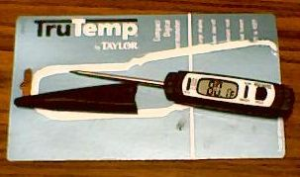

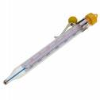

Digital Thermometer Candy Thermometer

You will also need a way to accurately measure out the water, and the fuel, for the test. I used a standard kitchen-measuring cup that is graduated in both ounces and milliliters (CC) for the water. To precisely measure the fuel, I purchased a 10-milliliter (CCs) medication dosage syringe for $1.50 that is graduated in tenths of milliliters (CCs). The syringe allows for precise measurement of the quantity of fuel to be used. These are available in any pharmacy.

Shown below: A common type of kitchen-measuring cup and a typical medication dosage syringe.

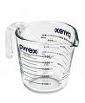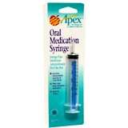

Since you probably would not want to drill a hole in the cover of your pot/pan, especially the pricey titanium stuff, you can substitute a piece of aluminum foil that is used to cover the pot/pan. I folded a piece of foil to make a cover that has 4 layers of foil. This allows for greater support of the thermometer, which is inserted through a hole in the foil, and also insulates the pot/pan.

If you use a stove that needs to be preheated, then THE PREHEAT FUEL MUST COME from the quantity of fuel calculated to contain the required BTUs needed to raise the water to 212 F. Using extra fuel to preheat the stove would throw off the results of the test.

Using the Spreadsheet:

Download the Excel spreadsheet (test.xls) to your PC’s desktop.

Enter the starting quantities (“Starting Temperature of Water”, “Expected Final Temperature of the Water”, and “Amount of Water to Heat”, in F or C, ounces or milliliters (CC)) in the highlighted boxes provided. This will generate the “Quantity of alcohol needed for the test burn” for methanol, iso-propanol, denatured alcohol and ethanol. (If anyone can provide BTU content figures for other types/brands of alcohol, or finds that the BTU contents values are in error, please contact us so that corrections and additions can be made.)

Running the test:

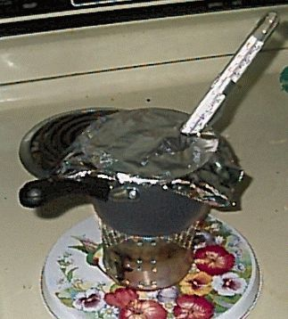

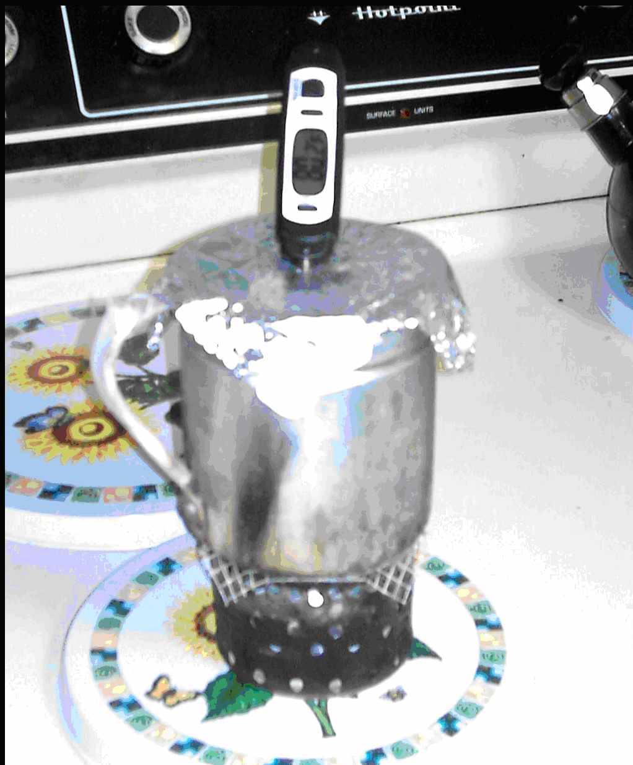

2 possible test setups

Use the test spreadsheet to determine the amount of alcohol fuel that you will need for the test burn.

- You will need to measure the starting temperature of the water and input this figure into the highlighted cell (line 13) of the spreadsheet.

- You will need to measure the expected final temperature of the water and input this figure into the highlighted cell (line 14) of the spreadsheet. If you live at a higher altitude, consult the “Altitude and Boiling Point Chart” at the bottom of the attached spreadsheet for an altitude-corrected boiling point.

- You will have to input the amount of water that you will use for the test into the highlighted cell (line 17) of the spreadsheet.

- Measure out the specified quantity of alcohol fuel needed for the test. (Line 24, 28, 32 or 36—depending on the type of alcohol you will be using.)

(The spreadsheet will automatically calculate the amount of alcohol fuel that you will need to run the test. Use the figure that is generated for the type of alcohol that you will be using…methanol, iso-propanol, denatured alcohol or ethanol.)

- Set up your stove system, fill your pot/pan with the measured quantity of water, insert the thermometer, add the calculated amount of alcohol fuel to your stove and fire it up.

- Note the final temperature of the water after the fuel burns out.

- The final step to determine the efficiency of the stove system under test is to enter the “Actual final water temperature” into the highlighted cell (line 18) of the spreadsheet. This will generate the “Actual % efficiency of the stove system”.

The following formula is used in the spreadsheet to calculate the efficiency of the stove system:

(Final temperature of water- Initial temperature of water)/ (212 F - Initial temperature of water) = % efficiency.

If the final temperature is, for example, only 60 degrees F, and our starting water temperature was 34 F, then the stove system is only 14.6 % efficient.

(60F-34F)/ (212F-34F) = 26/178=0.146 or 14.6%

Test results:

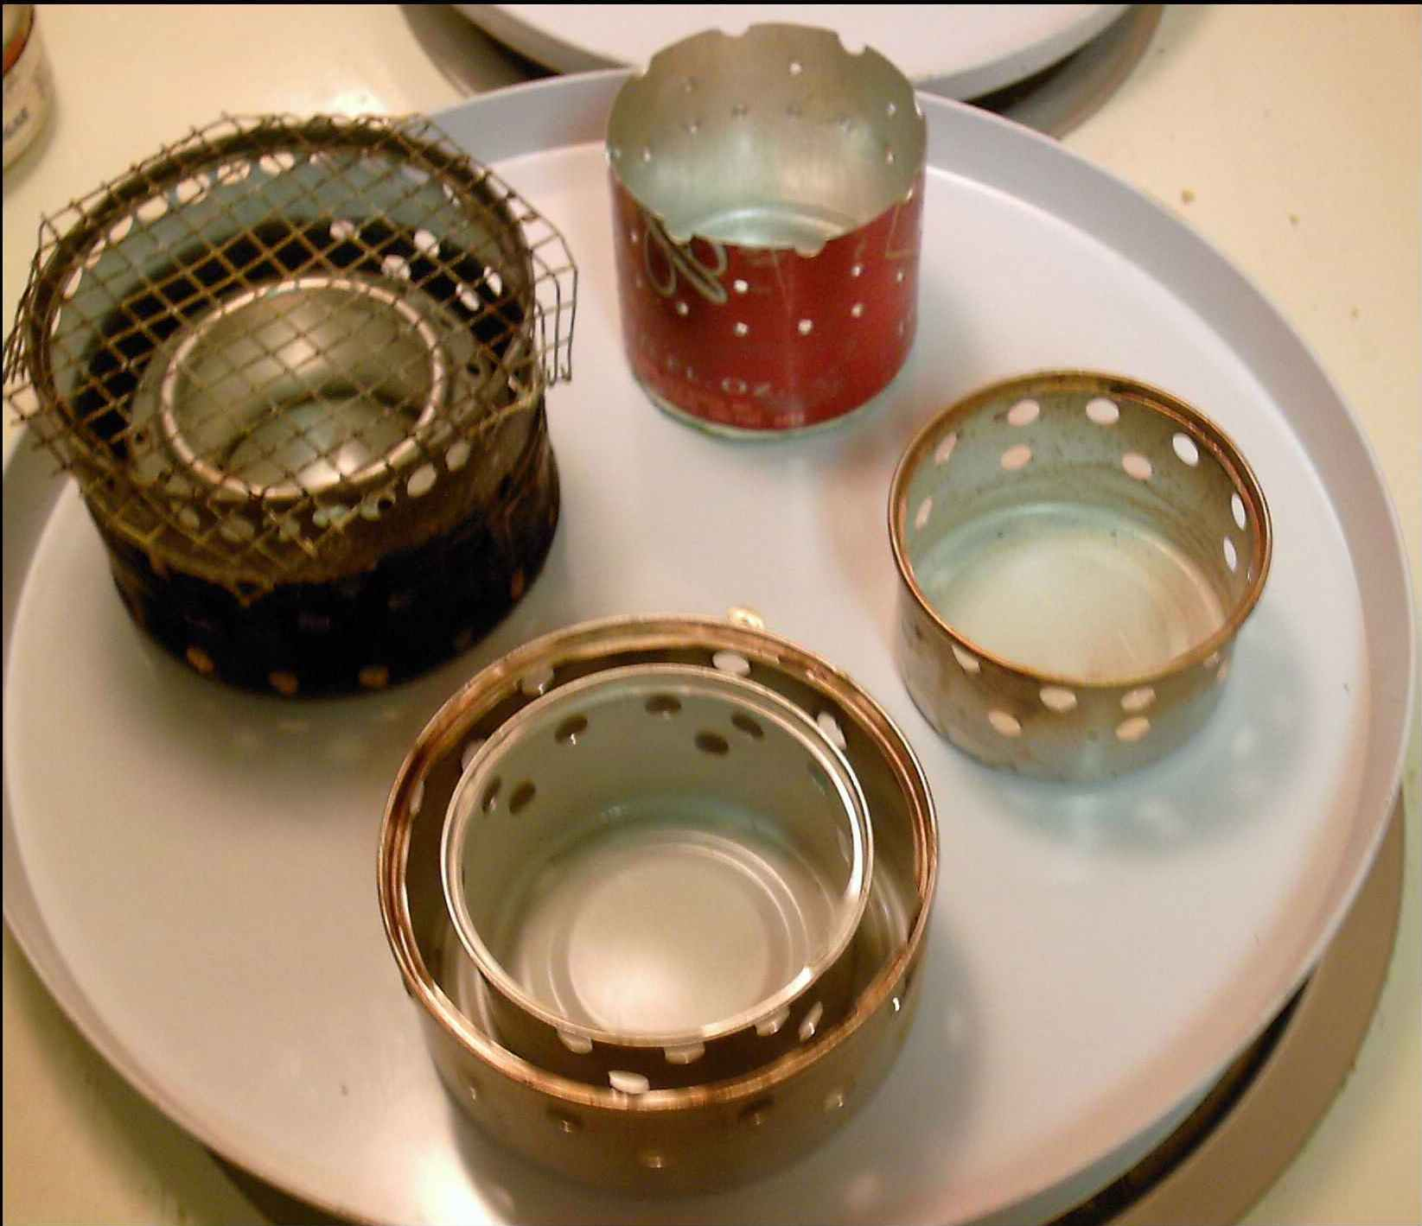
I tested 4 types of stoves, (shown above) :

- A Goya stove system, which uses a Pepsi can soda, stove insert.
(Check out atraildreamer’s project at www.backpacking.net.)

- A stove made from the bottom of aluminum Budweiser bottle.

- A cat stove that had 16_ ¼” holes in the top row and 11_ ¼” holes in the bottom row.

- A “Double Cat” stove, which is a 3” cat stove that is glued into a 5” cat food can that has 2 rows of 1/4 “holes punched every ½” around the larger can.

All tests, not including the “Double Cat”, were conducted with 16 ounces of refrigerated water at 40.5 degrees Fahrenheit. Inputting the amount of water and the initial temperature into the test spreadsheet generated an amount of 12 ml (cc) of Heet Yellow dry gas (Methanol) for the test burn. An Imusa grease pot (3 cup capacity) was used for the tests.

Initial test results:

Amount of Starting H2O Final H2O System Fuel Fuel
Stove System: H2O used: Temperature: temperature: efficiency: used: amount:
(Ounces) (Fahrenheit) (Fahrenheit) (%) (ML/CC)

Goya/Pepsi 16 40.5 136.3 55.9 Heet (Yellow) 12

Cat stove 16 40.5 122.9 48.0 Heet (Yellow) 12

Bud bottle 16 40.5 136.0 55.7 Heet (Yellow) 12

The Goya system gave the best initial efficiency of the three tested at 55.9%, with the Bud bottle stove coming in a close second at 55.7%. The cat stove was the easiest of the three to construct, and considering that it is not the best example of the cat stove design that is posted on the various forums; it gave a respectable 48% efficiency.

Some surprising test results:

A second round of tests was conducted, including the “Double Cat” stove. (The Double Cat stove is a 3” cat food can stove, which was glued into a larger 5” cat food can. Two rows of ¼” holes were punched into the side of the larger can with a spacing of ½”. Each the rows were about 3/8” apart).

(For the second test enter data into lines 68, 69 & 71 of the spreadsheet and use the fuel amounts listed for your fuel of choice on lines 56 through 64 of the spreadsheet. Variations in the initial and final temperatures of the water are allowed, but the same amount of water used in the initial test must be used in the second and third test burns. In other words, if you initially tested 16 ounces of water in the initial test, use 16 ounces of water in the follow-up tests).

On the second test burn, after factoring in the initial efficiency, the Goya stove system, actually showed a decrease in the efficiency of the system to 48.3%, down from 56.8%, and a lower than expected final temperature of 186.5 F! This decrease in efficiency apparently is the result of the larger quantity of fuel causing a higher pressure to be developed in the Pepsi can. This resulted in a more aggressive flame pattern that extended farther out of the Goya stove system heating the surrounding air, rather than the grease pot. A third test, using 24.5 ml of fuel got the water to 199.9F at an efficiency of 44.9%.

(For the third test, enter the data into lines 98, 99 & 101 and use the fuel amounts listed for your fuel of choice in lines 80 through 94).

Actual boiling conditions (where actual steam was observed coming out of the grease pot) required 26.4 ml of fuel, which pushed the water to 214.5 F at an efficiency of 45.5%. The 214.5 F temperature, which is 2.5 F above the normal sea level boiling point of 212 F, can be attributed to a slight “pressure cooker” effect caused by the tight-fitting foil covering the grease pot.

(The amount of fuel needed to heat the water to a steaming boil can be found for your fuel of choice in lines 110 through 124 of the spreadsheet. These quantities are calculated by combining the test results of the three burn tests.)

The cat stove showed an initial efficiency of 56.8%, dropped to 48.6& on the 2nd burn, and went back up to 56.1% on the 3rd burn, another unexpected result!

The initial Double Cat stove test showed an efficiency of 55.6% with a final water temperature of 135.2 F, but the burn took 17 minutes to complete on 12.1 ML of fuel! This should be of interest to trail cooks who like to slow-simmer their meals. The grease pot sitting on top of the Double Cat restricted the airflow causing the long burn time. A repeat of the test, using a hardware cloth wire mesh screen (borrowed from the Goya Stove system) sitting on top of the Double Cat resulted in a pitiful efficiency of 31.7%, with a final water temperature of 93.9 F, and a burn time of 8 minutes. The wire mesh apparently disrupted the laminar flow properties of the inner cat stove and allowed too much air into the system resulting in the lousy results.
Stove | Type | Fuel | Fuel | Amt (Oz) | Starting | Goal | Final | System
Type: | of Test: | Used: | AmT (ML): | H2O used: | Temp (F): | Temp(F): | Temp(F): | Efficiency:
Goya/Pepsi | Initial | Heet (Yellow) | 11.9 | 16 | 41.5 | 212 | 138.3 | 56.8%
Goya/Pepsi | 2nd burn | Heet (Yellow) | 21 | 16 | 41.5 | 212 | 186.5 | 48.3%
Goya/Pepsi | 3rd burn | Heet (Yellow) | 24.5 | 16 | 41.5 | 212 | 199.9 | 44.9%
Goya/Pepsi | Boil( steam) | Heet (Yellow) | 26.4 | 16 | 41.5 | 212 | 214.5 | 45.5%
Cat | Initial | Heet (Yellow) | 12.1 | 16 | 39.1 | 212 | 137.3 | 56.8%
Cat | 2nd burn | Heet (Yellow) | 21.3 | 16 | 39.1 | 212 | 190 | 49.6%
Cat | 3rd burn | Heet (Yellow) | 24.8 | 16 | 39.1 | 212 | 210 | 56.1%
Double Cat | Initial | Heet (Yellow) | 12.1 | 16 | 39.1 | 212 | 135.2 | 55.6%
Double Cat | Initial | Heet (Yellow) | 12.1 | 16 | 39.1 | 212 | 93.9 | 31.7%
W/screen

Does this prove that one type of stove is better than another? Not at all! I like the Goya Stove system, after all I invented it ☺ The Goya stove is a stove system that works pretty well for me. You can use the test setup and spreadsheet as a tool to test your favorite stove system and tweak it for maximum efficiency. Different types of alcohol fuels, pots, windscreens, height of stoves, etc., will have an effect on the test results. Test YOUR stove system and let us know what happens.

The numbers generated by the spreadsheet and the test burns will give you an idea of the amount of fuel that you need to carry, but they are not carved in stone!

A hiker should always carry an extra quantity of alcohol fuel to account for changing conditions and accidents, e.g.: spillage, changing temperature, etc.

Possible questions:

Q: Why use water?

A: its readily available everywhere.

Q: Does the water for the test have to be chilled?

A: No, use water at whatever temperature available. The spreadsheet uses whatever water temperature you enter for the calculations.

Q: What if my test water is frozen?

A: Find someplace warmer to camp. The spreadsheet does not provide for the melting of ice.

Q: Why did use only include information on 4 types of alcohols?

A: I could only find the information for these 4 types.
(Information on other types of alcohols would be appreciated.)

Q: Why include provisions to use Centigrade and milliliter (CC) values?

A: To keep the rest of the world happy.

Q: Why measure the alcohol fuel in milliliter (CC) values?

A: Much easier to measure than fractions of an ounce.

Q: Why are all but the input cells of the spreadsheet locked out?

A: I developed a significant headache putting together the spreadsheet, and I do not want the mathematically challenged to mess it up by changing the value(s) of a critical cell. If you want an unlocked copy of the spreadsheet, email me: atraildreamer@yahoo.com and I will forward to you an unprotected version of the spreadsheet.

Q: How will altitude changes affect my test?

A: I don’t plan on climbing a mountain to try this out; I’m going to do it in my kitchen, but if you need to adjust for altitude, see the chart at the bottom of the spreadsheet beginning at line 89.

Q: What about ambient air temperature?

A: What about it—I repeat, I am going to try this out in my kitchen.

Q: What about the starting temperature of the fuel?

A: I assume that it will be at room temperature, whatever that is, the fuel will get very hot when you light it up.

Q: Why do you have provision for 3 test burns?

A: As stated in the discussion of the test results, varying the amount of alcohol fuel caused a change in the efficiency of the stove system. Three tests will give the experimenter a better feel for the operation of a particular stove system and a close approximation of the amount of fuel that is needed to properly utilize a stove system.

Q: Can these tests be made more precise?

A: Sure…do you have a National Bureau of Standards laboratory that I can use for a while?

Q: Why did you come up with this method of testing stove efficiency?

A: To attempt to clear up a lot of confusion about the performance of various types of stove systems, and, possibly, to get a lot of people ticked off at me! ☺

Q: What should I avoid doing?

A: Burning down the homestead immediately comes to mind.

Q: What should I really avoid doing?

A: DO NOT USE GASOLINE!!!

Contact me:

atraildreamer@yahoo.com

